Advance HE Recognition - Written Application Guidance
Senior Fellow (SFHEA) (D3)

Your submission should consist of one single Microsoft Word document, consisting of the following sections:
Contents
Important information prior to completing your application 2
1. Career Biography 2
2: Record of Professional Activity 3
3: Critical Commentary: Demonstration of Professional and Development Activities 5
What to include 5
Support for your writing 8
4. Supporting Advocate Statements 9
Guidance Notes for PSF Advocates 10
5: Supporting evidence 11
Clarification of application (Viva) 11
Role of Mentor 12
Professional Standards Framework for SFHEA Level 13

Important information prior to completing your application
This document should be read in conjunction with the 2019 UK Professional Standards Framework which can be found on the UTA website and the MMU Senior Fellow Application Form. For reference, these standards are also attached at the end of this document.

In order to meet the requirements for Senior Fellow, you must demonstrate a thorough understanding of effective approaches to teaching and learning support as a key contribution to high quality student learning. You should be able to provide evidence of:
- Successful engagement across all five Areas of Activity;
- Successful engagement in appropriate teaching and practices related to the Areas of Activity;
- Appropriate knowledge and understanding across all aspects of Core Knowledge;
- A commitment to all Professional Values;
- Successful incorporation of subject and pedagogic research and/or scholarship within the above activities, as part of an integrated approach to academic practice;
- Successful engagement in continuing professional development in relation to teaching, learning, assessment and, where appropriate, related professional practices;
- Successful co-ordination, support, supervision, management and/or mentoring of others (whether individuals or teams) in relation to teaching and learning.

Submission instructions
All applications must be submitted to UTA via the PSF Recognition upload form. You can submit your claim at the following web address: https://utaresources.mmu.ac.uk/psfsubmission.
The UTA will review your application and will normally return feedback to you within 6 weeks of your submission.

1. Career Biography
Provide a brief summary of your career including details of relevant roles, institutions and qualifications and the values which underpin your practice.
Include in this section any relevant activities, past or current, that are external to the institution, such as external examining.
This section can be formatted as you wish (paragraphs, bulleted lists, etc) and should not exceed 250 words.

2: Record of Professional Activity
The professional activity grid enables you to demonstrate engagement with the dimensions of practice of the UK Professional Standards Framework Dimensions of Practice. For reference, these standards are also attached at the end of this document.

The grid should identify key activities that link to the overarching D3:vii in relation to your influence on colleagues’ practice and ensure that all dimensions of practice are also met. It should cover all dimensions of practice and a reasonable range of leadership/ mentorship activities. Generally, there is an expectation to demonstrate appropriate practice over an extended period of time (2-5 years).

Please focus mainly on current roles and responsibilities together with key activities of the last 2-5 years. You may include key activities from further back if they provide evidence of a key career development and still influence your practice. Ensure you incorporate examples of teaching-focussed CPD within the grid.

The grid should be sufficiently detailed but should not be excessive. Please ensure the grid does not exceed 4 pages in length.

For each example chosen:
- Select key examples that explicitly demonstrate your profile of sustained engagement with all Dimensions of Practice.
- In the space provided (Column 3), briefly explain any associated leadership and mentorship activities linked to your examples of professional activity; you do not need to do this for all activities included but ensure you clearly demonstrate your leadership and mentorship role.
- Include precise dates / time period for the activity – avoid using phrases such as ‘on-going’.

Table 1 overleaf shows some examples of SFHEA Professional Activities linked to the UKPSF.

Table 1: Example SFHEA Record of Professional Activity
Examples of professional activity | Sustained engagement with the Dimensions of Practice |  |  | Organisation/ leadership/ management of specific aspects of teaching and learning provision inc. successful coordination / support / supervision / management / mentorship of others. | Dates
 | AA1-5 | CK (1-6) | PV (1-4)
Led the Programme review of an undergraduate programme | A1-A5 | K1-K6 | V1-V4 | Leadership and co-ordination of programme team (20 staff). 12 unit leaders through curriculum development workshops and 1:1 / small team mentorship | 2016, 2018, 2021
Led the development of a new postgraduate degree programme | A1-A5 | K1-K6 | V1-V4 | Worked with HoD and other specialist staff to create the programme documentation for a new MSc | 2020
Led a team to redesign the VLE areas for all programmes within the department to offer online and blended approach to the curriculum for a programme teams | A1,A2, A4 | K1, K2, K4 | V1, V3 | Team coordination across several units and leadership of workshops and planning meetings | 2019-21
Mentorship of new academic staff | A5 |  |  | Regular mentorship of new colleagues on average 2-3 per year | 2016 - present
Core text book publication;  reference | A1, A4 | K1 | V3, V4 | Subject specific core text book that is a leader in the field and used by institutions world wide | 2018 - present
Completion of MA in HE | A1-A5 | K1-K5 | V1-4 | Developed theoretical and practical knowledge | 2020
Add more rows as required

3: Critical Commentary: Demonstration of Professional and Development Activities
Indicative word count: 5000 words + references

Once you have assembled your record of Professional Activity, you must write a reflective critical commentary that enables you to make a clear claim to support your engagement with Descriptor 3: Senior Fellow, as set out in the 2019 UKPSF.

This commentary should therefore “Demonstrate a thorough understanding of effective approaches to teaching and learning support as a key contribution to high quality student learning”. Senior Fellow claims must have the themes of leading, influencing, coaching others throughout, so ensure that this is present in your critical commentary.

Claimants must provide evidence of engagement with all of the following descriptors:
- Successful engagement with all AAs.
- Appropriate knowledge and understanding across all aspects of Core Knowledge.
- A commitment to all PVs.
- Successful engagement in appropriate teaching practices related to the AAs.
- Successful incorporation of subject and pedagogical research and/or scholarship, as part of an integrated approach to academic practice.
- Successful engagement in CPD in relation to teaching, learning, assessment, scholarship and, as appropriate, related academic and professional practice.
- Successful co-ordination, support, supervision, management, and/or mentoring of others in relation to teaching and learning.
D3.VII is the key requirement for SFHEA applicants and should ideally be embedded across the application. The demonstration of a sphere of influence that incorporates an influence on the practice of colleagues must be demonstrated by all SFHEA applicants

What to include
Within your critical reflective commentary, you should divide the commentary into 2 case studies which:
- Demonstrate your role in the provision of quality learning and teaching practice incorporating evidence of a thorough understanding of and sustained engagement with all the dimensions of practice.
  - Innovative teaching activities that also influence the practice of others are a useful example of practice to incorporate in your application as this will also evidence the overarching D3.vii .
- Provide evidence of your influence on the academic practice of colleagues through mentorship, co-ordination, support, supervision and management of colleagues. This activity should demonstrate that your influence has had a positive impact on colleagues’ practice and through this the students’ learning and teaching experience.
  - Avoid activities that focus solely on quality and/or administrative processes as these may not easily demonstrate the required impact on teaching and learning.

We recommend that you:
- Write in the first person incorporating examples from your practice so that the reviewers are able to ‘see’ your activities rather than read a theoretical discussion.
- Take ownership for your activities, discussing the active role you played in them, incorporating examples from your practice (Speak in terms of ‘I’, not ‘we’).
- Critically reflect on and explore you case studies, detail the decision process behind your actions and the evidence (research, theory or policy) which underpinned this practice. Show us the ‘how’ and ‘why’ of your practice.
- Indicate in brackets at the end of each paragraph the aspects of Areas of Activity, Core Knowledge and Professional Values you have referred to.
- Relate your discussion to the evidence, scholarly activity and/or research that has informed/shaped your engagement with this activity.
- Focus on current practice. If you discuss earlier practice, demonstrate how this still supports your current activities.
- Ensure you provide evidence of impact in the student experience – include concrete examples in your commentary and in the supporting evidence section.

Topics to demonstrate sustained engagement with the dimensions of practice could consist of:
- An example of innovative practice in teaching, learning and assessment, and / or
- An example of an activity within your teaching role that has clearly enhanced the student experience.

Topics to demonstrate appropriate engagement with D3.vii
- An example of curriculum development where you have led a team of staff eg: developing a new programme for validation.
- Sustained mentorship of a number of colleagues to achieve a change that has had an impact on teaching and learning practice and the student experience. Ensure there is sufficiency of mentorship over a period of time. (1 or 2 episodes of mentorship would not be sufficient.)
- The introduction of a new teaching and learning or assessment activity including mentorship/leadership of others that has then had a direct impact on the student experience.

Ensure you incorporate evidence of Impact within your discussion. This could include:
- Mentee, peer, senior staff/ line manager feedback on your role as a leader/mentor of others.
- Student/colleague/peer feedback on the examples chosen and what you have learned from this.
- Quality indicators such as student results, NSS/ISS scores.
- Feedback from external examiners, validation panel reports etc.

Evidence of scholarship underpinning your practice
There is an expectation that in this part of the application you evidence appropriate scholarship to underpin your teaching and learning practice. This will generally take the form of references to appropriate literature to support your described practice (use MMU Harvard referencing style). If you need to develop/update this area of your practice, the following are good sources:

- Ashton, S., & Stone, R. (2017). An AZ of creative teaching in higher education. Sage.
- Bates, B. (2019). Learning Theories Simplified:... and how to apply them to teaching. SAGE Publications Limited.
- The Journal of Further and Higher Education: https://www.tandfonline.com/toc/cjfh20/current
- Studies in Higher Education: https://www.tandfonline.com/toc/cshe20/current

Support for your writing
You might consider using the DRIVE model to guide your reflections. This was developed for use with colleagues applying for PSF fellowships and offers a useful structure for reflection.
D - Describe your activities or initiatives.
R – Provide a reason or rationale for doing what you did and for doing them in the way which you did. You might use literature to support this part.
I – State the impact of your activities. What was the impact on students, colleagues, yourself, and/or the discipline?
V/E – Provide verification or evidence of this impact.
You can view the full model and accompanying discussion at:
Knight, R.A. (2021). Supporting individuals to apply for reward and recognition – the DRIVE model of evidencing educational impact. City, University of London. Accessed 23 July 2021, via: https://blogs.city.ac.uk/learningatcity/2021/03/18/supporting-individuals-to-apply-for-reward-and-recognition-the-drive-model-of-evidencing-educational-impact/.

The University of Edinburgh has produced a great online toolkit to aid the production of academic reflections. You can find it at: https://www.ed.ac.uk/reflection/reflectors-toolkit/producing-reflections/academic-reflections

Finally, do not hesitate to contact the UTA for additional support on reflective writing.

4. Supporting Advocate Statements

Your application must be accompanied by two references, called advocate statements. The purpose of the statements is to:
- Validate the applicant’s engagement with the activities defined by Descriptor 3 (Advance HE Fellow);
- Validate the applicant’s engagement with the required dimensions of practice as defined by the UK PSF;
- Validate the applicant’s teaching, learning and assessment practice linked to the UK PSF Descriptor 3;
- Validate the experience claimed by the applicant in the experience grid, the written application, or presentation.

Your Advocate should be an experienced colleague, such as your line manager, who is able to comment, knowledgeably, and from first-hand experience, on your current role and any other relevant activities you have recently undertaken. They should align the statement directly with the UKPSF and Descriptor 3. Your referee should read your application prior to completing your statement.

Ideally, your advocate should be an Advance HE Senior or Principal Fellow, i.e. familiar with the requirements of the UK PSF. If you have difficulty identifying a suitable advocate please contact utacpd@mmu.ac.uk.

You will need to provide your advocate with the advocate statement proforma to complete (this proforma is held within the application form document). Please share this guidance document with your advocate, bringing the Advance HE PSF Requirements for SFHEA to their attention.

It is your responsibility to collect the advocacy statement and submit it with your application.

Guidance Notes for PSF Advocates
Please share the following guidance with your advocates:

Thank you for agreeing to take on the role of advocate for a submission for Senior Fellowship of the Higher Education Academy (HEA), now subsumed by Advance HE. Your time and effort is greatly appreciated.

Manchester Metropolitan’s Professional Recognition Framework is designed to enable staff involved in teaching and supporting learning to have their work recognised in one of four Descriptors (categories) of HEA Fellowship: D1 (Associate Fellow), D2 (Fellow), D3 (Senior Fellow) or D4 (Principal Fellow). Your role as an advocate is to confirm that the practice detailed in the individual’s submission is a true record of their work at the appropriate Descriptor level.

You have been approached because you know their work in detail and can verify the account given. Furthermore, by providing the Advocate Statement you are confirming that you support the participant's claim for Fellowship in their chosen Descriptor category. The participant will let you know the category they are submitting for and when they intend to submit. In order to prepare your statement, you should have sight of the applicant’s application document. The form of these can vary across the different levels of Fellowship.

The Advocate Statement Form is at the end of the completed application document. Please check that the claim provides an accurate picture of the participant’s experience and achievements in teaching and supporting learning. Your verification of the facts presented ensures the recognition process is fair and equitable.

Please write a paragraph of 350 – 500 words, validating the claims made. If appropriate, you can amplify relevant aspects of the applicant’s work, from your own perspective as e.g. line manager, team leader etc, providing practical examples to support your comments where possible. You may choose to make reference to particular dimensions on the framework (A1, A2 etc) but this is not necessary. You should however check that the dimensions underpin the individual’s practice in teaching and supporting learning, and that the individual meets each clause of the Descriptor relating to the category of fellowship they are submitting for. Please Email your completed form to the participant to include as part of their submission. Once again, many thanks for your support.

The MMU PSF Leads – March 2023

5: Supporting evidence
Supporting evidence can provide validation of impact evidence mentioned within the commentary. It does not provide additional evidence that is not referred to in the main application.
This documentation should not exceed four sides of A4 paper.
It can include:
- Evidence to support your engagement with peer observation of practice and any dialogue with your mentor. This may include:
- peer observation paperwork and feedback forms
- action plans
- Any evidence you wish to attach to provide supporting evidence of the impact of your teaching and supporting learning practice:
- Student feedback
- Peer feedback (other than peer observation)
- ISS/NSS data
- Excerpts from external examiner reports, committee minutes
- Testimonials
- Teacher awards
- A list of education-based publications/conference presentations

Please ensure that you maintain confidentiality and anonymity of students and colleagues when attaching this evidence.

Clarification of application (Viva)
Once your application has been reviewed the reviewers may defer making a decision as they require a little more evidence related to a narrow aspect of the application (usually related to one descriptor). In this case you will be invited to a short meeting (viva) with members from the review panel/team to enable you to provide additional evidence to the reviewers.

You will be informed in advance of the area of practice in question and have the opportunity to clarify this with the panel chair or lead reviewer. This will be arranged with you at mutually convenient time and will take a maximum of 15 minutes.

This is the usual option but you can request to submit further written evidence should you prefer.

Role of Mentor
Working with an experienced Senior Fellow or Principal Fellow is essential for success at SFHEA level and you should identify and approach a suitably mentor as early as possible. A list of current faculty-based mentors can be found here: https://www.mmu.ac.uk/about-us/professional-services/uta/prof-recognition-career-development/advance-he-recognition

Through dialogue, the mentor will support you in completing your application, acting as a critical friend. Identify a mentor as soon as possible. If there is not a suitable mentor available locally a UTA colleague will act as your mentor.

The mentor will:
- Support you in identifying a suitable focus for your reflective commentary.
- Participate in dialogue to support you in developing your reflective commentary.
- Read a draft of the application and give feedback.

Professional Standards Framework for SFHEA Level

Information below is taken from the Advance HE UK Professional Standards Framework, published in 2019.

Senior Fellowship of the HEA requirements

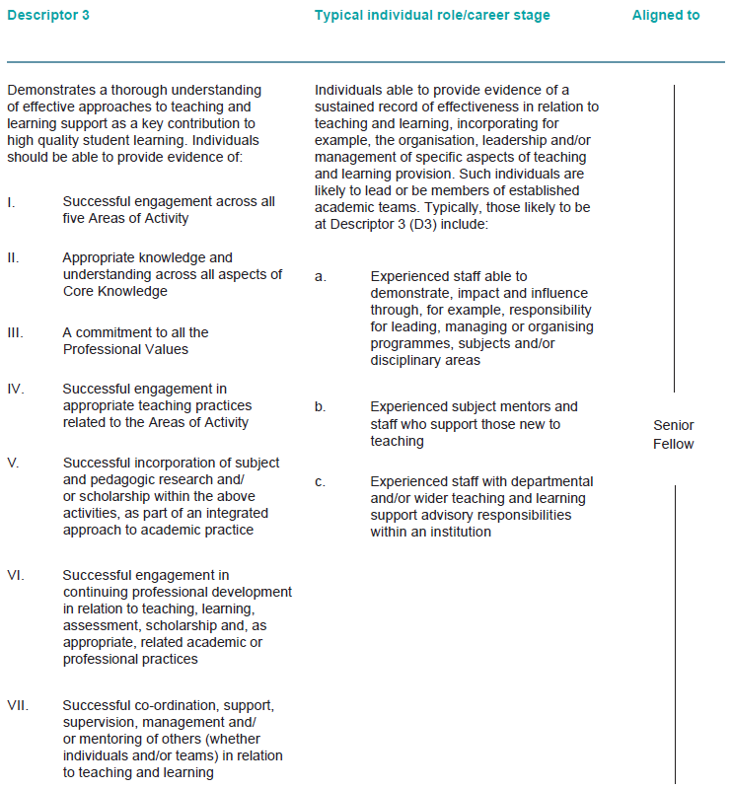

Professional Standards Dimensions
