Advance HE Recognition – Written Guidance
Principal Fellow (PFHEA) (D4)

Before preparing your claim, you must identify a mentor, who is able and willing to guide you through the process (they may offer up to three consultation meetings). You should prepare a single word-processed document, consisting of the sections below (explored in full in the rest of this guidance).
Contents
Important information prior to completing your application 2
Role of Mentor 3
1. Career Biography 4
2. Evidence of Professional Activity Grid 4
3. Reflective Commentary 7
4. Professional Discussion 9
5. Advocates 10
Guidance Notes for PSF Advocates 11
6. Supporting evidence 12
Appendix: Professional Standards Framework for PFHEA Level 13

Important information prior to completing your application
This document should be read in conjunction with the 2019 UK Professional Standards Framework which can be found on the UTA website and the MMU Principal Fellow Application Form. For reference, these standards are also attached at the end of this document.

To meet the requirements for Principal Fellow, you must demonstrate a sustained record of strategic leadership in academic practice and academic development as a key contributor to high quality student learning. Individual should be able to provide evidence of:
- Active commitment to and championing of all Dimensions of the Framework, through work with students and staff, and in institutional developments;
- Successful strategic leadership to enhance student learning, with a particular, but not necessarily exclusive, focus on enhancing teaching quality in institutional and/or (inter) national settings;
- Establishing effective organisational policies and/or strategies for supporting and promoting others (e.g. through mentoring, coaching) in delivering high quality teaching and support for learning;
- Championing, within institutional and/or wider settings, an integrated approach to academic practice (incorporating, for example, teaching, learning, research, scholarship, administration, etc);
- A sustained and successful commitment to, and engagement in, continuing professional development related to academic, institutional and/or other professional practices.

Submission instructions
All applications must be submitted to UTA via the PSF Recognition upload form. You can submit your claim at the following web address: https://utaresources.mmu.ac.uk/psfsubmission.
The UTA will review your application and contact you to arrange a 30-minute discussion with the review team at a mutually convenient time.

Role of Mentor
Working with an experienced Principal Fellow is mandatory and essential for success at PFHEA level.

You should identify and approach a suitably mentor as early as possible. A list of current faculty-based mentors can be found here: https://www.mmu.ac.uk/about-us/professional-services/uta/prof-recognition-career-development/advance-he-recognition

Through dialogue, the mentor will support you in completing your application, acting as a critical friend. Identify a mentor as soon as possible. If there is not a suitable mentor available locally a UTA colleague will act as your mentor.

The mentor will:
- Support you in identifying a suitable focus for your reflective commentary.
- Participate in dialogue to support you in developing your reflective commentary.
- Read a draft of the application and give feedback.

1. Career Biography
Provide a brief summary of your career relevant to your application for Principal Fellow. Include details of roles, institutions you have worked at and qualifications you have gained. When writing this, think about your audience and how you will convince them that the breadth and depth of your experience gives sufficient scope for a successful application (maximum 250 words).

2. Evidence of Professional Activity Grid
Use the grid to summarise your record of strategic leadership contributing to high quality student learning within Manchester Metropolitan University or wider (inter)national settings.

The grid should evidence:
- the sustained nature of your strategic leadership over a minimum of five years.
- the scope of your strategic leadership (breadth of activities and context).

Focus primarily on your last five years’ work, although it may be relevant to include earlier examples to demonstrate continuing impact of strategic leadership activities. Key activities should be expanded on within your critical commentary (see next section). For activities not further elaborated in the commentary, a concise explanation should indicate their significance, keeping this section to two pages max.

Notes for completing the grid:
- In column 1 identify relevant professional activities. Map the engagement of this activity to D4 i-v. Do not include everything you have done, select key activities that demonstrate engagement with strategic leadership across the criteria.
- To evidence D4 i (‘championing the UK PSF’) demonstrate engagement with all UK PSF dimensions of practice.
- Your research is included only where it relates directly to teaching and/or demonstrates a clear impact on wider educational practice.
- Your operational managerial roles are relevant only as related to strategically enhancing educational practice.
- Identify a range of activities that demonstrate strategic influence that extends institution-wide, or beyond.

Table 1: Example of a PFHEA Professional Activity Grid

Examples of Professional Practice | D4:i  Engagement with / Championing the Standards and Dimensions of the UK PSF | D4:ii  Strategic leadership in teaching and learning: | D4:iii  Policies and Strategies | D4:iv  Integrated Academic Practice | D4:v  Continuing Professional Development | Dates
Writing and implementing an institutional policy on learning and teaching | AA1,3,4 K2,3,4,5,6 V1,2,4 | √ | √ |  |  | 2020
Chair of a national PSRB Board | AA5, K1, 6 V4 | √ | √ |  |  | 2018-22
Author of internationally recognised text book in my subject area (reference) | AA5, K1, 2 V3 | √ |  | √ | √ | Published 2018
Cross-institutional leadership of a group to introduce a multi-disciplinary unit | AA1-5, K1-3, V 1-4 | √ |  | √ |  | 2018-22
Executive member of international professional specific education group setting the curriculum and international standards for UG teaching and learning in this professional area | AA1-4, K1, V3,4 | √ | √ |  | √ | 2017- present
Insert rows as needed

3. Reflective Commentary
Across a 7000-word commentary, Principal Fellows need to demonstrate “a sustained record of effective strategic leadership in academic practice and academic development as a key contribution to high quality student learning” (UK, PSF 2011, p7).

Within a large institution such as Manchester Met this could be evidenced by work impacting on the faculty, the institution, or beyond the institution, nationally or internationally.

The critical commentary will be analytical and evaluative in nature informed by a critical reflection on your practice. A descriptive account will not be sufficient, you need to explain an informed rationale for the actions you took, the decisions you made, and demonstrate the impact of the outcomes.

The following reflective questions may help you articulate relevant activities fully:
- What did I do? – a brief description to initiate your critical analysis.
- Why did I do it in that way? – choices made, decisions taken, your rationale.
- What scholarship supports my approach? - e.g. pedagogical or leadership literature incorporated as a means of underpinning your practice with appropriate theoretical concepts.
- What was the impact of my activities, and what evidence can I include to support the claim of impact on the institution, its staff and the students’ experience?
- What have I learnt from this experience about myself as a leader and /or the institution?
- Where do I go from here? – including changes made by others following your activities.

We recommend you structure your written commentary to focus on your engagement with D4: ii, iii and iv, and then within this integrate evidence of your engagement with the other elements.

The claim can be presented as 1-3 case studies that cover:
- Strategic leadership in teaching and learning;
- Development of strategic policies and strategies linked to teaching and learning;
- Development of integrated academic practice.

Unpacking the elements of the descriptors:
4.i Active commitment to and championing of the Dimensions of the Framework through working with staff and students

This should be explicitly incorporated across your commentary, “This means being a role model and modelling the behaviours encompassed in the UKPSF through your own practice, setting up conditions in which staff and students can engage with learning, promoting a holistic view of learning, teaching and assessment which is underpinned by the dimension of UKPSF within the institution” (HEA, 2016). for D4.ii - 4.iv)”.

4.ii Strategic leadership in teaching and learning
Reflect on strategic activities you have led that have enhanced the quality of the student experience leading to a demonstrable impact on teaching quality within institutional and/or national and/or international settings. Strategic leadership can include influence on student support, rather than teaching per se, as a key benefit to the student experience. Strategic leaders do not necessarily hold a senior managerial position, and can include staff from information and technical services, registrars, and research leads. In all cases it is essential to demonstrate impact on outcomes for students and the student experience. Some projects and activities will be endorsed by Executive or Academic Board, in which case you may refer to institutional objectives and mission statements, demonstrating how you have led activities to meet these strategic targets and the consequential impact on student learning and the quality of teaching. Some activities may be collaborative in nature, and in this case demonstrate your leadership role within the group and the specific aspects of outcomes you successfully led.

4.iii Policies and Strategies

Provide examples of where you have established organisational level policies/strategies. The policy must relate to the ‘supporting and promoting of others’ and could include policies linked to colleagues’ teaching and learning performance or policies that provide development and support in relation to enhancing teaching and learning choosing sufficiently mature examples to make your ongoing impact clear.

4.iv Integrated Academic Practice
Teaching in higher education takes place in a complex environment where we may have a multiplicity of roles involving teaching, management, leadership, mentoring, research, administration and various forms of service to the HE community. Demonstrate how you champion an integrated approach to academic practice as a manager, leader, mentor, researcher and/or administrator within your own practice, and show you encourage others to do the same. Reflect on how the ‘roles’ enable you to carry out an ‘integrated approach to academic practice’. For example, how may your research link to your scholarship and your role as a leader, and how does this then influence teaching and learning in a strategic way?

This criterion is about making an impact on other people’s academic practice, how policies and strategies have changed the academic culture. D4.ii and D4.iv are frequently linked; a policy which has had a benefit to the student experience usually also has an impact on academic practice. An example of this would be the introduction of online marking and feedback where the applicant has demonstrated the impact of improving the student experience and also changing academic practice.

4.v A sustained and successful commitment to, and engagement in, continuing professional development’
Do not limit yourself to listing formal CPD courses completed; evidence other CPD opportunities such as internal committees and working groups, contributing to external organisations and professional bodies in relation to learning and teaching development. Leadership courses/qualifications may also be relevant and can also form part of the experience grid.

4. Professional Discussion
All PFHEA written claimants must engage with a professional discussion with the PSF review panel. This discussion will last around 30 minutes and will be arranged at a mutually convenient time between yourself and the review team once they have reviewed your documentation. This gives the panel the opportunity to clarify any aspects of the application where appropriate, and will enable you to expand on aspects of your reflective commentary that need a little more explanation.

5. Advocates
Your application must be accompanied by three advocate statements, including one advocate external to MMU. Advocates should be experienced staff able to act as an advocate for your PFHEA application by commenting, knowledgeably, and from first-hand experience, on your current role and any other relevant activities you have recently undertaken.

At least one advocate must:
- be a Fellow (or Senior or Principal Fellow) of AdvanceHE;
- be able to comment on the ways in which you have directly influenced their own practice;
- be external to your institution;
- be from a higher education provider.

The role of the advocacy statement is to:
- Confirm the validity of the evidence referred to within the application.
- Provide additional practical examples to support the impact of the applicant’s practice on the student experience.

The advocate should:
- Comment on your teaching and learning focussed activities and provide examples to support your strategic leadership in this area.
- Provide real world examples of how your work has supported, influenced and affected them/or the practice of others.
- Show that your activities meet the requirements of the UKPSF Descriptor 4.
- Endorse your experience and achievements in strategic teaching and learning leadership.

Please share the guidance overleaf with your advocate and share a mature copy of your application with them.

Once you have completed your application, it is your responsibility to collect the advocate statements and submit them with your application.

Guidance Notes for PSF Advocates
Please share the following guidance with your advocates:

Thank you for agreeing to take on the role of advocate for a submission for Principal Fellowship of the Higher Education Academy (HEA), now subsumed by Advance HE. Your time and effort is greatly appreciated.

Manchester Metropolitan’s Professional Recognition Framework is designed to enable staff involved in teaching and supporting learning to have their work recognised in one of four Descriptors (categories) of HEA Fellowship: D1 (Associate Fellow), D2 (Fellow), D3 (Senior Fellow) or D4 (Principal Fellow). Your role as an advocate is to confirm that the practice detailed in the individual’s submission is a true record of their work at the appropriate Descriptor level.

You have been approached because you know their work in detail and can verify the account given. Furthermore, by providing the Advocate Statement you are confirming that you support the participant's claim for Fellowship in their chosen Descriptor category. The participant will let you know the category they are submitting for and when they intend to submit. In order to prepare your statement, you should have sight of the applicant’s application document. The form of these can vary across the different levels of Fellowship.

The Advocate Statement Form is at the end of the completed application document. Please check that the claim provides an accurate picture of the participant’s experience and achievements in teaching and supporting learning. Your verification of the facts presented ensures the recognition process is fair and equitable.

Please write a paragraph of 350 – 500 words, validating the claims made. If appropriate, you can amplify relevant aspects of the applicant’s work, from your own perspective as e.g. line manager, team leader etc, providing practical examples to support your comments where possible. You may choose to make reference to particular dimensions on the framework (A1, A2 etc) but this is not necessary. You should however check that the dimensions underpin the individual’s practice in teaching and supporting learning, and that the individual meets each clause of the Descriptor relating to the category of fellowship they are submitting for. Please Email your completed form to the participant to include as part of their submission. Once again, many thanks for your support.

The MMU PSF Leads – March 2023

6. Supporting evidence
It can strengthen your application if you include a selection of significant supporting evidence, but please ensure that supporting evidence is focussed and kept under four pages in length. This could include:
- Testimonials;
- excerpts documents evidencing evaluations of activity;
- evidence of ongoing reflective practice such as excerpts from or link to reflective diary /blog;
- a list of education-based publications/conference presentations;
- Other evidence to support your engagement with the UK PSF and Descriptor 4 (PFHEA).

Appendix: Professional Standards Framework for PFHEA Level
Information below is taken from the Advance HE UK Professional Standards Framework, published in 2019.

Principal Fellowship of the HEA requirements

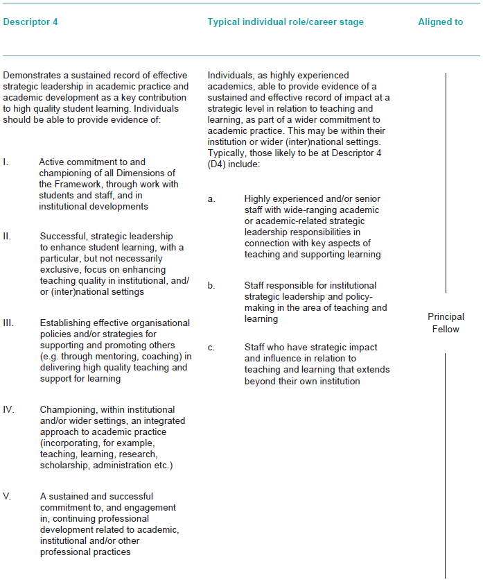

Professional Standards Dimensions
