Advance HE Recognition - Presentation Application Guidance
Associate Fellow (AFHEA) (D1)
Ahead of your presentation, you should prepare a single Microsoft Word document, consisting of the following sections (explored in full in the rest of this guidance):
Contents
Important information prior to completing your application 2
1. Career Biography 3
2. Experience Grid: Evidence of Professional Activity 3
3. Supporting Advocate Statement 5
Guidance Notes for PSF Advocates 6
4: Supporting Evidence 7
5: Presentation Content 8
Support for your presentation 9
Guidance on completing each area of activity 10
A1: Design and plan learning activities / and or programmes of study 10
A2: Teach and / or support student learning 10
A3: Assess and give feedback to learners 10
A4: Develop effective learning environments and approaches to student support and guidance 10
A5: Engage in CPD in subjects/disciplines and their pedagogy, incorporating research, scholarship and the evaluation of professional practice 11
The Live Presentation Process 12
The Recorded Presentation Process 12

Important information prior to completing your application
This document should be read in conjunction with the 2019 UK Professional Standards Framework which can be found on the UTA website and the MMU Associate Fellow Application Form. For reference, these standards are also attached at the end of this document.

In order to meet the requirements for Associate Fellow, you must demonstrate an understanding of specific aspects of effective teaching, learning support methods and student learning. You should be able to provide evidence of:
- Successful engagement with at least two of the five Areas of Activity;
- Successful engagement in appropriate teaching and practices related to these Areas of Activity;
- Appropriate Core Knowledge and understanding of at least K1 and K2;
- A commitment to appropriate Professional Values in facilitating others’ learning;
- Relevant professional practices, subject and pedagogic research and/or scholarship within the above activities;
- Successful engagement, where appropriate, in professional development activity related to teaching, learning and assessment responsibilities.

Submission instructions
All applications must be submitted to UTA via the PSF Recognition upload form. You can submit your claim at the following web address: https://utaresources.mmu.ac.uk/psfsubmission.
If you are wishing to deliver a ‘live’ presentation, indicate this on the PSF Recognition Upload Form and a UTA colleague will contact you to arrange a convenient time.

If you are submitting a recorded presentation, please include a link to the recording when uploading your application form at the above Upload Form. The UTA will review your application and will normally return feedback to you within 6 weeks of your submission.

1. Career Biography
Provide a brief summary of your career including details of relevant roles, institutions and qualifications and the values which underpin your practice.
Include in this section any relevant activities, past or current, that are external to the institution, such as external examining.
This section can be formatted as you wish (paragraphs, bulleted lists, etc) and should not exceed 250 words.

2. Experience Grid: Evidence of Professional Activity
Within this grid you should describe examples of your professional activity, cross-referenced with the relevant Areas of Activity (AA), Core Knowledge (CK) and Professional Values (PV) set out in the UK Professional Standards Framework Dimensions of Practice. For reference, these standards are also attached at the end of this document.

For Advance HE Associate Fellow (AFHEA) you must evidence engagement with two Areas of Activity, as well as Core Knowledge 1 & 2 and any appropriate professional values. You should also demonstrate engagement with any other relevant Core Knowledge and Professional Values. For each Professional Activity selected, cross-reference it with the appropriate Areas of Activity, Core Knowledge and Professional Values. Activities such as unit leadership may engage with all dimensions.

You do not need to include everything that you do in the grid but you should select key examples that explicitly demonstrate engagement with the required Dimensions of Practice. The grid can include up to 10 activities.

In each example of activity, use the left hand column to explain briefly what you have been doing, and use the other columns to link this activity to the Dimensions of Practice and the dates / time period of the activity. Ensure that you include examples of your CPD engagement (eg relevant courses/workshops attended) within the grid. Table 1 below shows some examples of Professional Activities linked to the UKPSF.

Table 1: Example of AFHEA Activities Mapped to UKPSF
Professional activity | Broad engagement with the dimensions of practice |  |  | Dates
 | Areas of Activity  AA1-5 | Core Knowledge  CK1-6 | Professional Values  PV1-4
Delivery of workshops for students on study skills and assessment techniques | A2, 4 | K1-4 | V1-3 | September 2016 to date
Delivery of 1:1 student tutorials on assessment writing and academic writing | A2, 3 | K1-4 | V1-3 | September 2018 to date
Provision of assessment retake support and guidance for individual students | A3, 4 | K2, 3, 4 | V1, 2 | September 2018 to date
Design of a VLE area on study skills and assessment writing | A3, 4 | K2, K3, K4 | V1-3 | August 2019
Participation in peer observations of practice and professional dialogues on practice | A5 | K5, 6 | V3, 4 | Annually x2 2016 - date
Attendance at staff development sessions on using screencasts for learning and teaching | A5 | K2, K4 | V1, V3 | Sept 2020

3. Supporting Advocate Statement

Your application must be accompanied by a reference, called the advocate statement. The purpose of the statement is to:
- Validate the applicant’s engagement with the activities defined by Descriptor 1 (Advance HE Associate Fellow);
- Validate the applicant’s engagement with the required dimensions of practice as defined by the UK PSF;
- Validate the applicant’s teaching, learning and assessment practice linked to the UK PSF Descriptor 1;
- Validate the experience claimed by the applicant in the experience grid, the written application, or presentation.

Your Advocate should be an experienced colleague, such as your line manager, who is able to comment, knowledgeably, and from first-hand experience, on your current role and any other relevant activities you have recently undertaken. Your referee should read your application prior to completing your statement.

Ideally, your advocate should be an Advance HE Fellow, Senior Fellow or Principle Fellow, i.e. familiar with the requirements of the UK PSF. If you have difficulty identifying a suitable advocate please contact utacpd@mmu.ac.uk.

You will need to provide your advocate with the advocate statement proforma to complete (this proforma is held within the application form document). Please share this guidance document with your advocate, bringing the Advance HE 2019 PSF Requirements for AFHEA to their attention.

It is your responsibility to collect the advocacy statement and submit it with your application.

Guidance Notes for PSF Advocates
Please share the following guidance with your advocates:

Thank you for agreeing to take on the role of advocate for a submission for Associate Fellowship of the Higher Education Academy (HEA), now subsumed by Advance HE. Your time and effort is greatly appreciated.

Manchester Metropolitan’s Professional Recognition Framework is designed to enable staff involved in teaching and supporting learning to have their work recognised in one of four Descriptors (categories) of HEA Fellowship: D1 (Associate Fellow), D2 (Fellow), D3 (Senior Fellow) or D4 (Principal Fellow). Your role as an advocate is to confirm that the practice detailed in the individual’s submission is a true record of their work at the appropriate Descriptor level.

You have been approached because you know their work in detail and can verify the account given. Furthermore, by providing the Advocate Statement you are confirming that you support the participant's claim for Fellowship in their chosen Descriptor category. The participant will let you know the category they are submitting for and when they intend to submit. In order to prepare your statement, you should have sight of the applicant’s application document. The form of these can vary across the different levels of Fellowship.

The Advocate Statement Form is at the end of the completed application document. Please check that the claim provides an accurate picture of the participant’s experience and achievements in teaching and supporting learning. Your verification of the facts presented ensures the recognition process is fair and equitable.

Please write a paragraph of 350 – 500 words, validating the claims made. If appropriate, you can amplify relevant aspects of the applicant’s work, from your own perspective as e.g. line manager, team leader etc, providing practical examples to support your comments where possible. You may choose to make reference to particular dimensions on the framework (A1, A2 etc) but this is not necessary. You should however check that the dimensions underpin the individual’s practice in teaching and supporting learning, and that the individual meets each clause of the Descriptor relating to the category of fellowship they are submitting for. Please Email your completed form to the participant to include as part of their submission. Once again, many thanks for your support.

The MMU PSF Leads – March 2023

4: Supporting Evidence

Supporting evidence can provide validation of impact evidence mentioned within the commentary. It does not provide additional evidence that is not referred to in the main application. This documentation should not exceed four sides of A4 paper.
It can include:
- Evidence to support your engagement with peer observation of practice and any dialogue with your mentor, such as
- peer observation paperwork and feedback forms
- action plans
- Any evidence you wish to attach to provide supporting evidence of the impact of your teaching and supporting learning practice, such as
- Student feedback
- Peer feedback (other than peer observation)
- ISS/NSS data
- Excerpts from external examiner reports, committee minutes
- Testimonials
- Teacher awards
- A list of education-based publications/conference presentations

Please ensure that you maintain confidentiality and anonymity of students and colleagues when attaching this evidence.

5: Presentation Content

Critical Commentary: Demonstration of Professional and Developmental Activities
Once you have assembled the above documentation, you need to then choose two of the 5 Areas of Activity to discuss during a 20 minute presentation. This presentation can be delivered in one of two ways:
- Live – A live delivery of your 20 minute presentation to the reviewing team (consisting of two reviewers). This may be face-to-face or over Microsoft Teams. It will be recorded for moderation purposes.
- Recorded – A prerecorded screencast of your presentation, lasting 20 minutes in duration. This is submitted as a hyperlink within your application form documents.

Choose an activity that will allow you to reflect critically on the effectiveness of the activity and the quality of the student learning and/or the student experience.

Ensure that within this presentation you make a clear claim to support your engagement with the requirements of Associate Fellowship – these are outlined below, as set out in the UK PSF.

We recommend that you:
- Take ownership for your activities, discussing the active role you played in them, incorporating examples from your practice (Speak in terms of ‘I’, not ‘we’).
- On each slide, indicate in brackets which aspects of the Areas of Activity, Core Knowledge and Professional Values you have referred to.
- Relate your discussion to the evidence, scholarly activity and/or research that has informed/shaped your engagement with this activity.
- Focus on current practice. If you discuss earlier practice, demonstrate how this still supports your current activities.
- Ensure you provide evidence of impact upon the student experience – include concrete examples in your commentary and in the supporting evidence section.

Potential sources of evidence for all areas of activity might include:
- Feedback from peer observations / students /surveys / colleagues
- ISS scores /NSS scores
- Unit statistics
- Nomination for teacher/supporting learning awards

Evidence of scholarship underpinning your practice
There is an expectation that in this part of the application you evidence appropriate scholarship to underpin your teaching and learning practice. This will generally take the form of references to appropriate literature to support your described practice (use MMU Harvard referencing style). If you need to develop/update this area of your practice, the following are good sources:

- Ashton, S., & Stone, R. (2017). An AZ of creative teaching in higher education. Sage.
- Bates, B. (2019). Learning Theories Simplified:... and how to apply them to teaching. SAGE Publications Limited.
- The Journal of Further and Higher Education: https://www.tandfonline.com/toc/cjfh20/current
- Studies in Higher Education: https://www.tandfonline.com/toc/cshe20/current

Support for your presentation
You might consider using the DRIVE model to guide your reflections. This was developed for use with colleagues applying for PSF fellowships and offers a useful structure for reflection.
D - Describe your activities or initiatives.
R – Provide a reason or rationale for doing what you did and for doing them in the way which you did. You might use literature to support this part.
I – State the impact of your activities. What was the impact on students, colleagues, yourself, and/or the discipline?
V/E – Provide verification or evidence of this impact.
You can view the full model and accompanying discussion at:
Knight, R.A. (2021). Supporting individuals to apply for reward and recognition – the DRIVE model of evidencing educational impact. City, University of London. Accessed 23 July 2021, via: https://blogs.city.ac.uk/learningatcity/2021/03/18/supporting-individuals-to-apply-for-reward-and-recognition-the-drive-model-of-evidencing-educational-impact/.

The University of Edinburgh has produced a great online toolkit to aid the production of academic reflections. You can find it at: https://www.ed.ac.uk/reflection/reflectors-toolkit/producing-reflections/academic-reflections.

Finally, do not hesitate to contact your mentor or the UTA for additional support on developing your presentation.

Guidance on completing each area of activity
Remember, for Associate Fellow you only need to complete two of the following five Areas of Activity. If you do not select A5 ensure you incorporate evidence of engagement in appropriate CPD in the above grid and in one of your selected sections.

A1: Design and plan learning activities / and or programmes of study
Examples of suitable activities:
- Involvement in design/redesign of workshops, 1:1 tutorials, webinars, etc.
- Design/planning of workshops, sessions and guidance documents.
- Development of technology-enhanced learning resources .

A2: Teach and / or support student learning
Examples of suitable activities:
- Lectures, tutorials, seminars, practicals, labs, studios, screencasts, podcasts, placement support / fieldwork, personal tutoring, dissertation supervision, PG student supervision, mentoring, contributing to staff development programmes.

A3: Assess and give feedback to learners
Examples of suitable activities (delivering/designing/evaluating):
- Written and/or verbal feedback to learners and peers, examinations, written assignments, presentations, portfolio.

A4: Develop effective learning environments and approaches to student support and guidance
Examples of suitable activities:
- Personal tutoring/individual pastoral or tutorial support.
- Moving to and from the physical environment and virtual environment.
- Inclusive practice - ensuring all learners have access to learning opportunities.
- Liaison and planning in support of placement / fieldwork.
- Addressing access via widening participation or for students with disabilities.

A5: Engage in CPD in subjects/disciplines and their pedagogy, incorporating research, scholarship and the evaluation of professional practice
Examples of suitable activities:
- Formal courses eg PGCert
- Informal / non-accredited courses and workshops eg In-service training
- Conference attendance
- Personal reading and reflection
- Engagement with peer observations and dialogues.

The Live Presentation Process
Presentation panels are now being conducted over MS Teams to allow for flexible working arrangements in the university and are arranged ad-hoc to suit claimants availability. However, if you wish to deliver a face-to-face presentation, please discuss this with the lead reviewer.
Process:
- Once you have submitted your documents, you will be contacted by the lead reviewer to arrange a mutually convenient time for your presentation between yourself, the lead reviewer and second reviewer.
- Once agreed, you will be sent a calendar invite for a specific date and time to deliver your presentation.
- At the allocated time/date, you and the reviewers will join the MS Teams meeting and introduce yourselves. If this is done face to face then this will involve meeting at a reagreed room.
- The lead reviewer will then start the recording and you will deliver your presentation.
- The panel will then ask you to leave the Teams meeting/meeting room while they discuss your application and invite you back in after 5-10 minutes.
- The reviewers may defer making a decision as they require a little more evidence related to a narrow aspect of the application (usually related to one descriptor). In this case, you will be invited to discuss this aspect to enable you to provide additional evidence to the reviewers.
- The lead reviewer will then close the session, stop the recording, and inform you of the next steps.
- You will normally receive a decision on the outcome of your AFHEA claim within 1 working day.

The Recorded Presentation Process
You will put your application form document together and include a hyperlink to your recorded presentation within this document. Please ensure that sharing/privacy permissions have been adjusted on your chosen platform so that colleagues can view the video (This may be MS Stream, MMUTube, Youtube, OneDrive, Google Drive, etc). This will then be uploaded to the PSF Recognition Upload Form at the same time.
Once submitted, UTA will review the documents and communicate their decision on the outcome of your AFHEA claim within 6 weeks. If the review team feel they need further clarification, they may invite you for a short discussion to clarify those elements.
Professional Standards Framework for AFHEA Level
Information below is taken from the Advance HE UK Professional Standards Framework, published in 2019.

Associate Fellowship of the HEA requirements
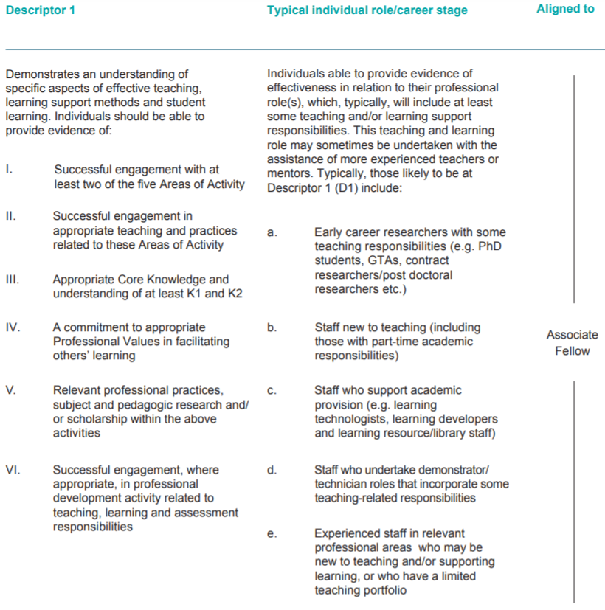

Professional Standards Dimensions
